Determining Longest Common Subsequences of Two Sequences on a Linear array of Processors
Amar Mukherjee
Application Specific Array Processors,1992.
Proceedings of the International Conference on , 1992 , pp. 526 -537

Abstract
- Introduction
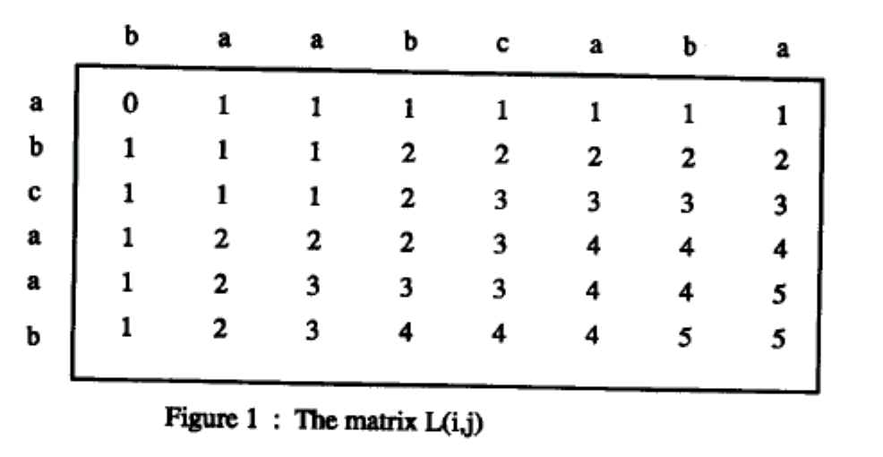
- Boolean matrix
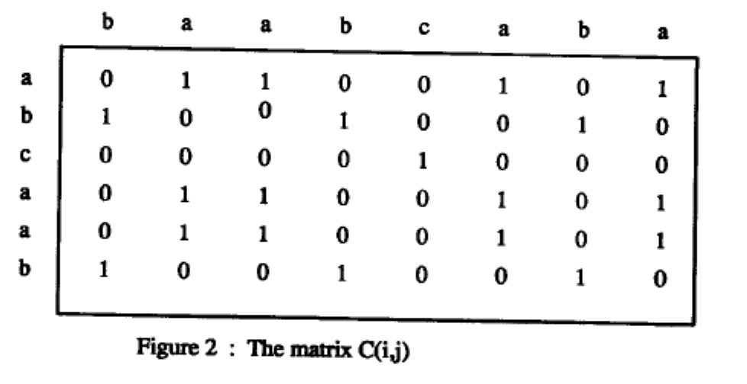
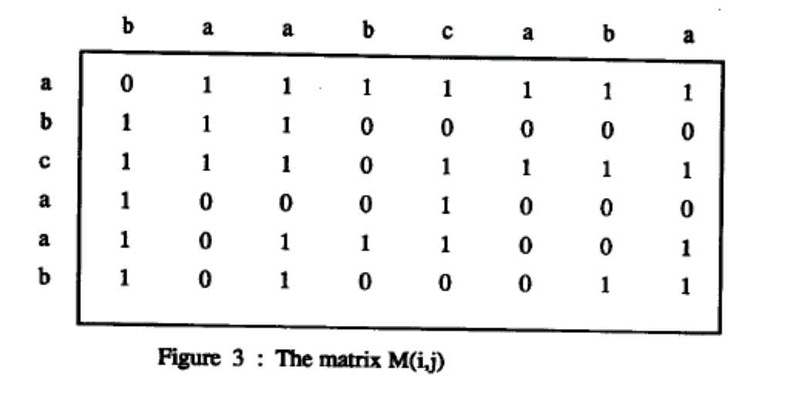
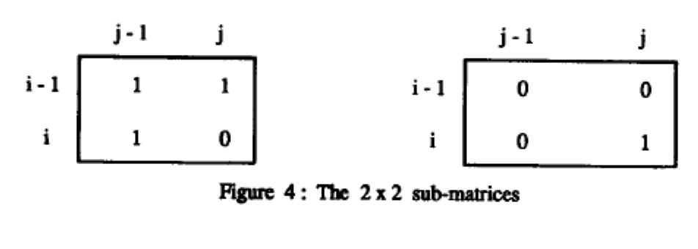
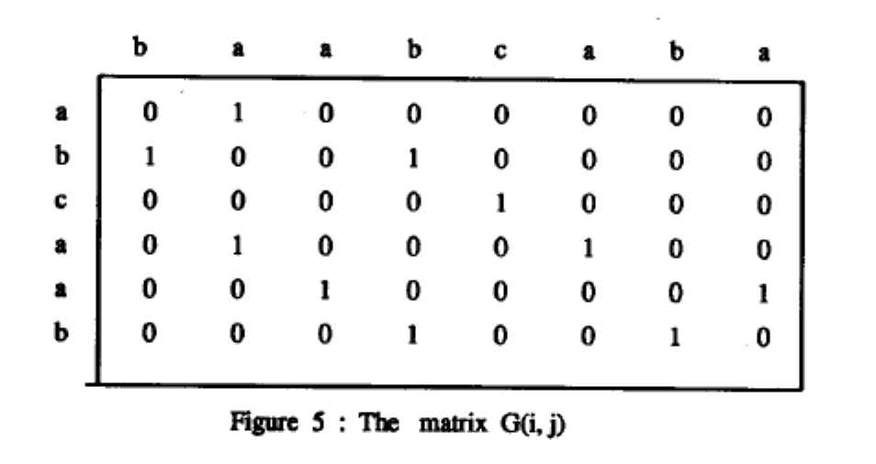
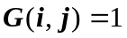
if
or

L1=[(1,2),(2,1)] , L2=[(2,4),(4,2)] ,
L3=[(3,5),(5,3)] , L4=[(4,6),(6,4)] , L5=[(5,8),(6,7)]
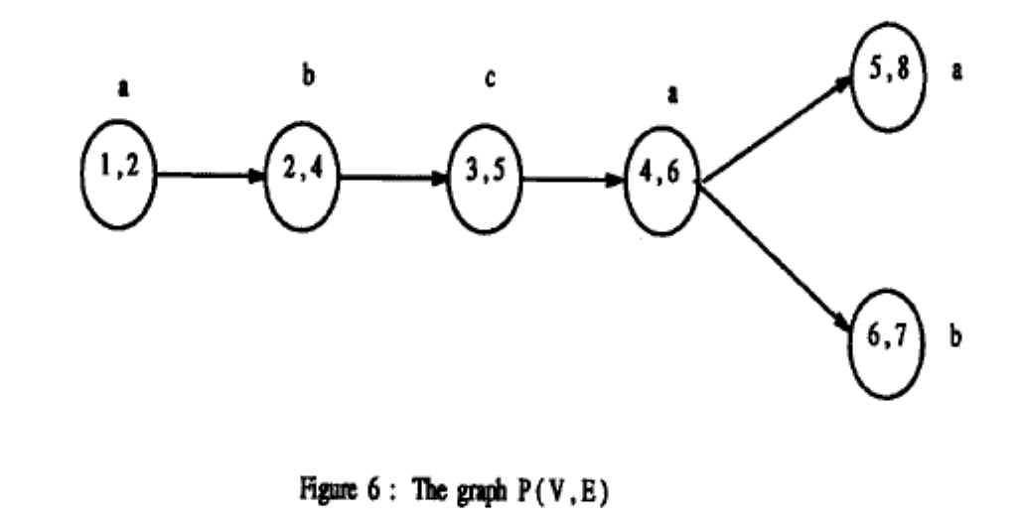
- Hardware Algorithms
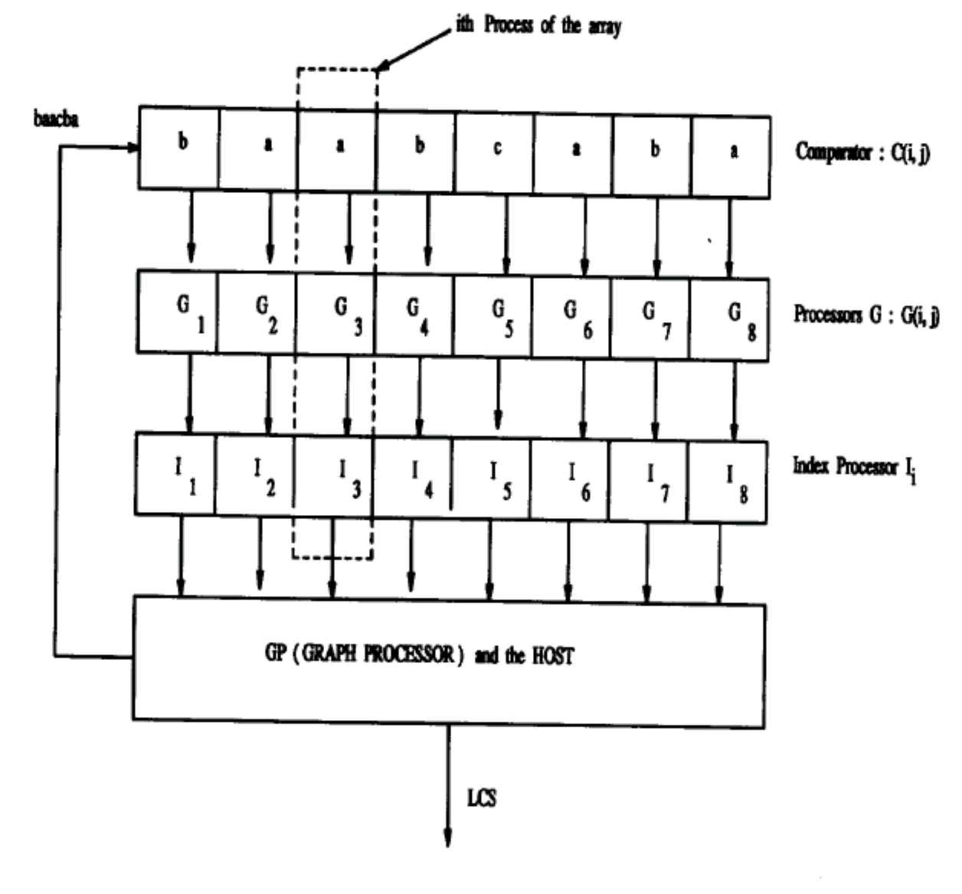
- Concluding Remarks

Created by : Kuen-Feng Huang

Date : Apr. 11, 2000

